24CSI024-DATA STRUCTURES AND ALGORITHMS
UNIT 1-INTRODUCTION TO DATA STRUCTURES AND ALGORITHMS
Arrays and Array-Based Techniques (Two-Pointer, Sliding Window, Prefix Sums)
LAB WORKBOOK-09.07.2026

CATEGORY: EASY
Question 1: Squaring a Sorted Array (Two-Pointer)
Anjali is processing seismic intensity readings stored in a non-decreasing sorted array. The readings can contain negative values (representing reverse-phase wave intensities) as well as positive values. To calculate the kinetic energy of these waves, she needs to square each value and return a new array containing the squares, sorted in non-decreasing order.
She must perform this operation in 𝑂(𝑁) time using the two-pointer technique:
1. Initialize a left pointer at index 0 and a right pointer at index N - 1.
2. Compare the absolute values of arr[left] and arr[right].
3. Square the larger absolute value and place it at the end of the output array (starting from index N - 1 and moving backwards).
4. Move the corresponding pointer (left inward or right inward) and repeat until the output array is filled.
• The first line of input consists of an integer 𝑁 representing the number of readings.
• The second line of input consists of 𝑁 space-separated integers representing the sorted wave intensities (can contain negative numbers).
• Print a single line of 𝑁 space-separated integers representing the sorted squared values
• 1≤𝑁≤10000
• −104 ≤𝑎𝑟𝑟[𝑖] ≤ 104
• The input array is sorted in non-decreasing order.
Input 1:
codeText
5 -4 -1 0 3 10
Output 1:
codeText
0 1 9 16 100
Input 2:
codeText
4 -7 -3 2 3
Output 2:
codeText
4 9 9 49
AIM:
To write a C program that squares every element of a sorted array and returns the squared values in sorted order using the Two Pointer Technique.
PSEUDO CODE:
left = 0
right = N - 1
pos = N - 1
while left <= right
if abs(arr[left]) > abs(arr[right])
output[pos] = arr[left] * arr[left]
left++
else
output[pos] = arr[right] * arr[right]
right--
pos--
CODE:
#include<stdio.h>
#include<stdlib.h>
int main()
{
int n;
scanf("%d", &n);
int arr[n];
int ans[n];
for(int i = 0; i < n; i++)
{
scanf("%d", &arr[i]);
}
int l = 0;
int r = n - 1;
int in = n - 1;
while(l <= r)
{
if(abs(arr[l]) > abs(arr[r]))
{
ans[in] = arr[l] * arr[l];
l++;
}
else
{
ans[in] = arr[r] * arr[r];
r--;
}
in--;
}

for(int i = 0; i < n; i++)
{
printf("%d ", ans[i]);
}

return 0;
}
OUTPUT:
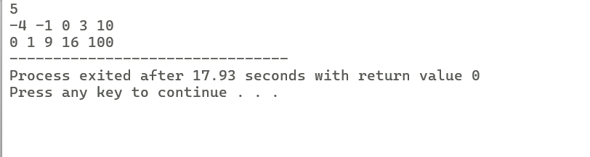
RESULT:
Thus, the program successfully generated the sorted squared array using the Two-Pointer technique in O(N) time.

Question 2: Cumulative Resource Consumption (Prefix Sum)
Kabir is monitoring a data transmission line. He receives a log of data packets transmitted each hour over a period of 𝑁 hours. To generate an hourly usage report, he wants to compute the cumulative running sum of packets transmitted from the start of the log up to each hour. Write a program that takes the hourly logs and outputs the prefix sum array representing the cumulative data volume.
• Let the prefix sum array be P.
• P[0] = arr[0]
• P[i] = P[i-1] + arr[i] for 𝑖 ≥ 1.
• The first line of input consists of an integer 𝑁 representing the number of hours.
• The second line consists of 𝑁 space-separated integers representing the packets transmitted each hour.
• Print a single line of 𝑁 space-separated integers representing the cumulative running sum at each hour.
• 1≤𝑁≤10000
• 0≤𝑎𝑟𝑟[𝑖]≤ 105
Input 1:
codeText
5 10 20 5 15 30
Output 1:
codeText
10 30 35 50 80
Input 2:
codeText
3 0 0 5
Output 2:
codeText
0 0 5
AIM:
To write a C program to compute the Prefix Sum array from the given input array.
PSEUDO CODE:

prefix[0] = arr[0]
for i = 1 to N-1
prefix[i] = prefix[i-1] + arr[i]
Print prefix array
Stop
CODE:
#include<stdio.h>
int main()
{
int n;
scanf("%d", &n);
int arr[n];
int sum = 0;
for(int i = 0; i < n; i++)
scanf("%d", &arr[i]);
for(int i = 0; i < n; i++) {
sum += arr[i];
printf("%d ", sum);
}
return 0;
}
OUTPUT:
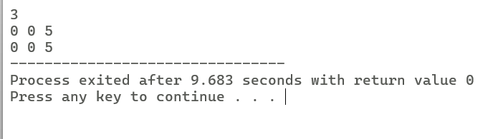
RESULT:
Thus, the program successfully computed the Prefix Sum array representing the cumulative sums of the given array.

CATEGORY: MEDIUM
Question 3:Grouping Active Sectors (Fixed-Size Sliding Window)
Sam is working on a flash storage defragmentation algorithm. The sectors of the storage drive are represented by a binary array of size 𝑁, where 1 represents an active data sector and 0 represents an empty sector. To optimize read operations, Sam wants to group all active sectors (1s) together in a contiguous block. He wants to find the minimum number of swaps required to bring all 1s together. This can be solved in 𝑂(𝑁) time using a sliding window:
1. Count the total number of 1s in the array. Let this count be 𝐶. If 𝐶 is 0 or 1, no swaps are needed.
2. Find a contiguous subarray (window) of size 𝐶 that contains the maximum number of 1s.
3. The minimum number of swaps required is then 𝐶 minus the maximum number of 1s found in any window of size 𝐶.
• The first line of input consists of an integer 𝑁 representing the number of sectors.
• The second line of input consists of 𝑁 space-separated binary values (0 or 1).
• Print a single integer representing the minimum swaps required in the format: Min Swaps: X.
• 1≤𝑁≤10000
• arr[i] is either 0 or 1.
Input 1:
codeText
6 1 0 1 0 1 0
Output 1:
codeText
Min Swaps: 1
Input 2:
codeText
5 1 1 1 0 0
Output 2:
codeText
Min Swaps: 0
AIM:
To write a C program to find the minimum number of swaps required to bring all 1's together using the fixed size sliding window technique.
PSEUDO CODE:
Get input for N
If C <= 1
Print 0
Stop
Store as maxOnes
Remove left element
Add next right element
Update maxOnes
Minimum Swaps = C - maxOnes
Stop
CODE:
#include <stdio.h>
int main() {
int n;
scanf("%d", &n);
int arr[n];
int c = 0;
for(int i = 0; i < n; i++)
{
scanf("%d", &arr[i]);
if(arr[i] == 1)
c++;
}
if(c <= 1)
{
printf("Min Swaps: 0");
return 0;
}
int current = 0;
for(int i = 0; i < c; i++)
current += arr[i];
int max = current;
for(int i = c; i < n; i++)
{
current = current - arr[i - c] + arr[i];
if(current > max)
max= current;
}
printf("Min Swaps: %d", c- max);
return 0;
}
OUTPUT:
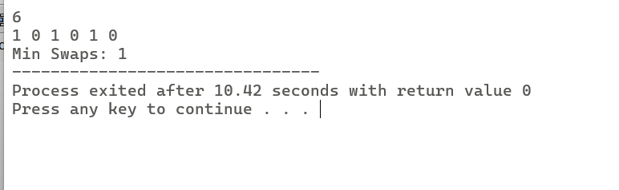
RESULT:
Thus, the program successfully determined the minimum number of swaps required to group all active sectors together using the Sliding Window technique.

Question 4. Maximum Task Window Within Budget (Variable-Size Sliding Window)
Riya is scheduling a pipeline of processes on an embedded processor. Each process 𝑖 has a known energy cost arr[i]. The processor has a strict power limit 𝑃 for any contiguous execution sequence. Riya wants to find the maximum number of consecutive tasks she can execute without their combined energy cost exceeding the limit 𝑃. She uses a variable-size sliding window:
1. Maintain a start pointer at index 0 and a running sum of energy current_sum.
2. Iterate an end pointer from 0 to N - 1 and add arr[end] to current_sum.
3. If current_sum exceeds 𝑃,increment start and subtract arr[start] from current_sum until current_sum <= P.
4. Keep track of the maximum window size (end - start + 1) encountered during the process.
• The first line of input consists of two space-separated integers: 𝑁 (the number of tasks) and 𝑃 (the maximum allowed energy consumption).
• The second line of input consists of 𝑁 space-separated positive integers representing the energy costs of the tasks.
• Print a single integer representing the maximum consecutive tasks in the format: Max Length: X.
• 1≤𝑁≤10000
• 1≤𝑎𝑟𝑟[𝑖]≤ 104
• 1≤𝑃≤108
Input 1:
codeText
5 8 3 1 2 4 5
Output 1:
codeText
Max Length: 3
Input 2:
codeText
4 5 6 7 8 9
Output 2:
codeText
Max Length: 0
AIM:
To write a C program to find the maximum number of consecutive tasks whose total energy consumption does not exceed the given limit using the variable size sliding window technique.
PSEUDO CODE:
start = 0
Sum = 0
maxL = 0
for end = 0 to N-1
Sum += arr[end]
while Sum > P
Sum -= arr[start]
start++
Print maxL
CODE:
#include <stdio.h>
int main() {
int n, p;
scanf("%d %d", &n, &p);
int arr[n];
for(int i = 0; i < n; i++)
scanf("%d", &arr[i]);
int s = 0;
int current = 0;
int max = 0;
for(int e= 0; e < n; e++) {
current+= arr[e];
while(current > p && s <= e) {
current-= arr[s];
s++;
}
int l = e- s + 1;
if(l> max)
max = l;
}
printf("Max Length: %d", max);
return 0;
}
OUTPUT:
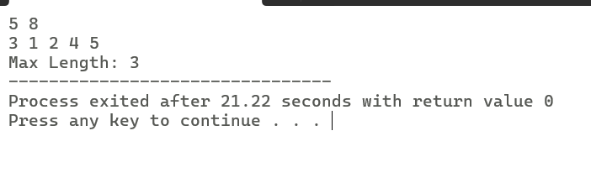
RESULT:
Thus, the program successfully found the maximum number of consecutive tasks that can be executed within the given energy budget using the Variable-Size Sliding Window technique.

CATEGORY: HARD
Question 5: Sliding Window Maximum Peak (Monotonic Window Queue)
Rohan is building a real-time graphics rendering system. The system receives a sequence of frame rendering times. To smooth out frame drops, Rohan must calculate the peak (maximum) rendering time in every sliding window of 𝐾 consecutive frames. To achieve an optimal 𝑂(𝑁) runtime, Rohan uses a monotonic double-ended queue (deque) to store indices of elements in the sliding window:
1. As the window slides from left to right, maintain the deque such that indices of elements are stored in decreasing order of their corresponding values.
2. For each element arr[i]: o Remove indices from the back of the deque if their corresponding values are less than or equal to the current element arr[i] (they can no longer be the maximum). o Insert the current index i at the back of the deque. o Remove the index from the front of the deque if it falls outside the bounds of the current sliding window (i.e., if the index is less than i - K + 1).
3. For every step where the window is fully formed (when i >= K - 1), the element at the index stored at the front of the deque is the maximum for that window. Note: Since standard C does not have a built-in deque, you can implement a basic deque using a pre allocated array of size 𝑁 with front and rear pointer indices.
• The first line of input consists of two space-separated integers: 𝑁 (the total number of frames) and 𝐾 (the sliding window size).
• The second line of input consists of 𝑁 space-separated integers representing the frame rendering times.
• Print a single line of space-separated integers representing the maximum value for each sliding window of size 𝐾.
• 1≤𝐾≤𝑁≤10000
• −105 ≤𝑎𝑟𝑟[𝑖] ≤ 105
Input 1:
codeText
8 3 1 3 -1
-3 5 3 6 7
Output 1:
codeText
3 3 5 5 6 7
Input 2:
codeText
4 2 4 3 2 1
Output 2:
codeText
4 3 2
AIM:
To write a C program to find the maximum element in every sliding window of size K using monotonic queue
PSEUDO CODE:
for i ← 0 TO n – 1
while front index ≤ i - k
Remove front
End while
while rear value ≤ current value
remove rear
end while
insert current index at rear
if i ≥ k - 1
Print front value
end if
CODE:
#include <stdio.h>
int main()
{
int n, k;
scanf("%d %d", &n, &k);
int arr[n];
for (int i = 0; i < n; i++)
scanf("%d", &arr[i]);
int dq[n];
int front = 0;
int rear = -1;
for (int i = 0; i < n; i++)
{
while (front <= rear && dq[front] <= i - k)
front++;
while (front <= rear && arr[dq[rear]] <= arr[i])
rear--;
dq[++rear] = i;
if (i >= k - 1)
printf("%d ", arr[dq[front]]);
}
return 0;
}
OUTPUT:

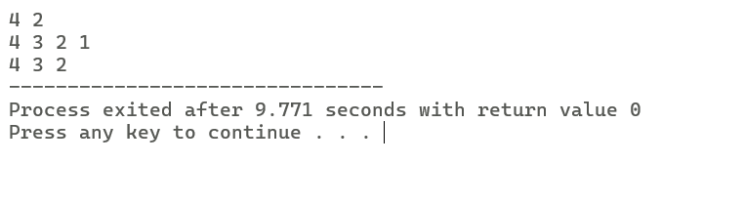
RESULT:
Thus, the program successfully found the maximum element in every sliding window of size K using the Monotonic Queue technique with O(N)time complexity.

VIVA QUESTIONS:
- "We often describe a 'List' or a 'Queue' as an Abstract Data Type (ADT), while an 'Array' is a concrete data structure. In C, which lacks native object-oriented classes, how do we enforce the separation between an ADT's interface and its underlying array implementation?"

An abstract data type tells us what operations w can perform ,like insert,delete or search.it does not tell us how they are implemented.An array is the actual data structure used to store the data.In C,the header file contains the function declarations and source file contains the array implementation.

- "When using the two-pointer approach to find a pair with target sum 𝑇 in a sorted array, we increment left if the sum is too small, and decrement right if the sum is too large. Intuitively, why are we guaranteed not to 'miss' the correct pair by skipping elements? Why is backtracking unnecessary?"

The array is already sorted so if the sum is smaller than the target moving the left pointer increases the sum,if the sum is larger than the target,moving the right pointer decreases the sum.array is sorted and every moves takes closer to the answer.

- "If we are given an unsorted array and asked to find a target sum pair, we have two main options: sort the array first and use two pointers, or use a lookup table (hash map). How do you evaluate the trade-offs between these two approaches in a resource-constrained embedded system?"

The hash map is faster bcause it finds the pair in O(n) but needs extra memory.Sorting+two pointers takes O(nlogn) time,but uses less extra memory.memory is limited so sorting and two pointers is usually the better choice
- "Why does the classic variable-size sliding window technique (expanding end and contracting start) fail to find a subarray summing to 𝑆 if the input array contains negative integers?"

The sliding window works only when all nubers are positive.With negative adding removing an element can increase or decrese the sum .Because ,the window cannot decide to shrink or expand so the methos fails.

- "Prefix sum arrays allow us to perform range sum queries in 𝑂(1) time. However, what is the computational cost of updating a single element in the original array if we want to keep our prefix sum array valid, and how does this affect our choice of data structure?"

If one element changes,all the prefix sums after the position also change.so we need to update every value that will take O(n) time.Thats are many queries but very few updates

- "When passing an array to a C function that implements a sliding window algorithm, what actually gets passed to the function? Why can't we use the sizeof operator inside the function to determine the size of our window or array?"

When array is send to function only the address of the first element is passed.Inside the function sizeof(array) gives the size of the pointer,not the size of entire array.So we should pass array size separately.

- "What major runtime vulnerability or logic error can occur when constructing a prefix sum array of a large dataset of integers in C, even if the individual elements fit within standard data types? How do we mitigate this?"

The main problem occurs will be integer overflow.Even if each element fits in an integr adding many values together may exceed the integer limit.In this cases we can avoid this by using larger data type like long long.

- "Suppose you are designing a heart rate monitor. Contrast a scenario where you would use a fixed-size sliding window with a scenario where you would use a variable-size sliding window on the sensor data."

A fixed size sliding monitor x=can calculate the average heart rate of the last 10 seconds.A variable size sliding window can find the longest continuous period where the heart rate stays below the safe limit

- "In the 'Sliding Window Maximum' problem (Hard), why can we safely discard an index 𝑗 from the back of our monotonic deque when a new element at index 𝑖 (𝑖 > 𝑗) is introduced such that arr[i] >= arr[j]?"

If the new elment is larger than or equal to the previous one, the smaller element can never become maximum while the new element is still inside the window.So we remove it to keep the deque efficient

- "If we wanted to calculate the average brightness of any arbitrary sub-rectangle of an image in 𝑂(1) time, how would you extend the concept of a 1D prefix sum array to a 2D grid? What would a single 'cell' in the 2D prefix sum represent?"

We create a 2D prefix sum arrayEach cell stores the sum of all values from the top left corner to that cell.Using this we can find the sum or average of any rectangular area inO(n) time.

